# Exercício 04 – Algoritmos e Grafos

1. **a)**

1 → 2

2 → 3

3 → 1 → 4 → 6

4 → 3 → 5

5 → 6 → 9

6 →

7 → 6 → 11

8 → 7 → 10 → 11

9 → 6 → 8

10 → 5 → 9

11 → 7

|  |  |  |  |  |
| --- | --- | --- | --- | --- |
|  | Status | Predecessor | Descoberta | Finalizado |
| 1->2 | P | - | 1 | 22 |
| 2->3 | P | 1 | 2 | 21 |
| 3->1->4->6 | P | 2 | 3 | 20 |
| 4->3->5 | P | 3 | 4 | 19 |
| 5->6->9 | P | 4 | 5 | 18 |
| 6 | P | 5 | 6 | 7 |
| 7->6->11 | P | 8 | 10 | 13 |
| 8->7->10->11 | P | 9 | 9 | 16 |
| 9->6->8 | P | 5 | 8 | 17 |
| 10->5->9 | P | 8 | 14 | 15 |
| 11->7 | P | 7 | 11 | 12 |

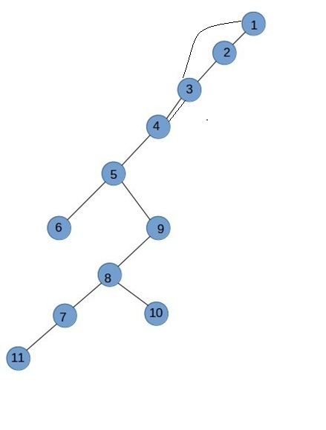

**b)**

Possui apenas 1 componente.

C) Possui 2 ciclos

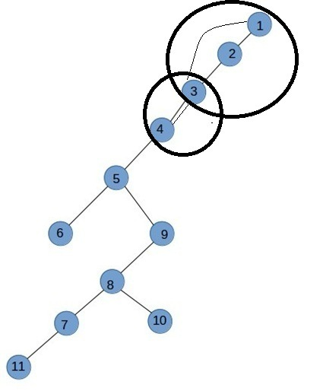

# 2.

0->6->1->5

1->2

2->6

3

4->11->9->3

5->3->4

6->7

7->8->10

8

9->11

10->8

11->12

1